**Advanced Orchestration with Kubernetes**

**Process:**

**Set Up AWS Resources**

Logged in to AWS Management Console.  
• Launched 3 EC2 Instance: (virtual machine - Ubuntu).

1 Master machine and 2 wokker machine (3 nodes)

And security groups to allowed HTTP (port 80) and SSH (port 22) traffic with instance type - T2.medium and 15Gb disk size and created PPK file.

**Connect to Your EC2 Instance**

•    Used SSH to connect to EC2 instance using the PPK file via Putty as below.

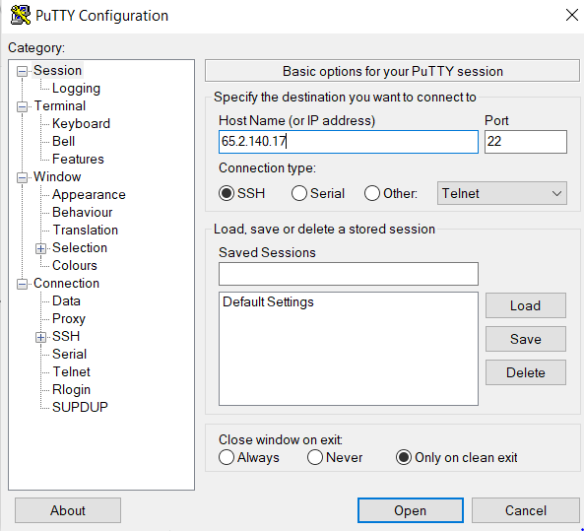

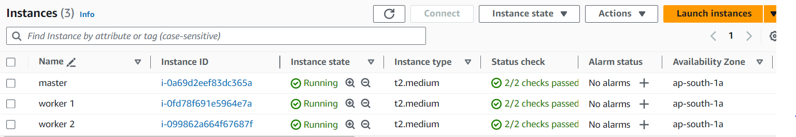

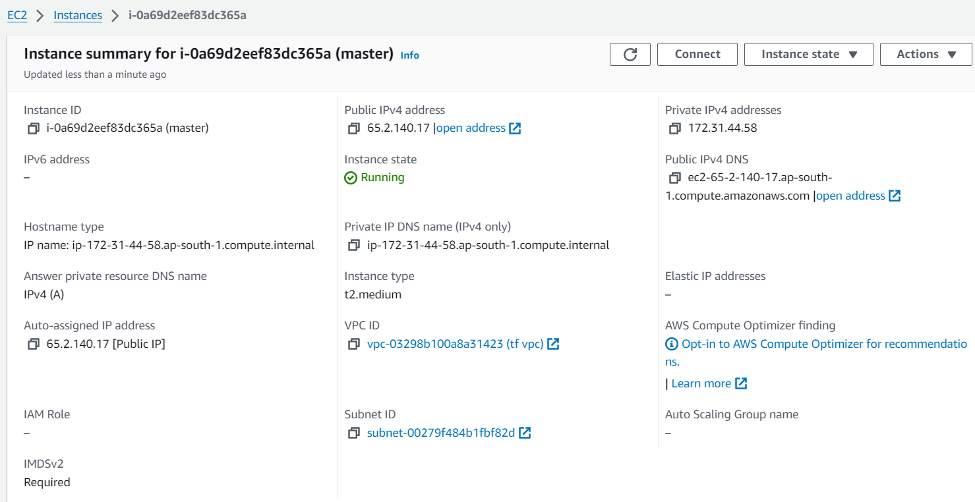

Updated the system's package list and install necessary dependencies using the following commands on three (Master and worker machines)

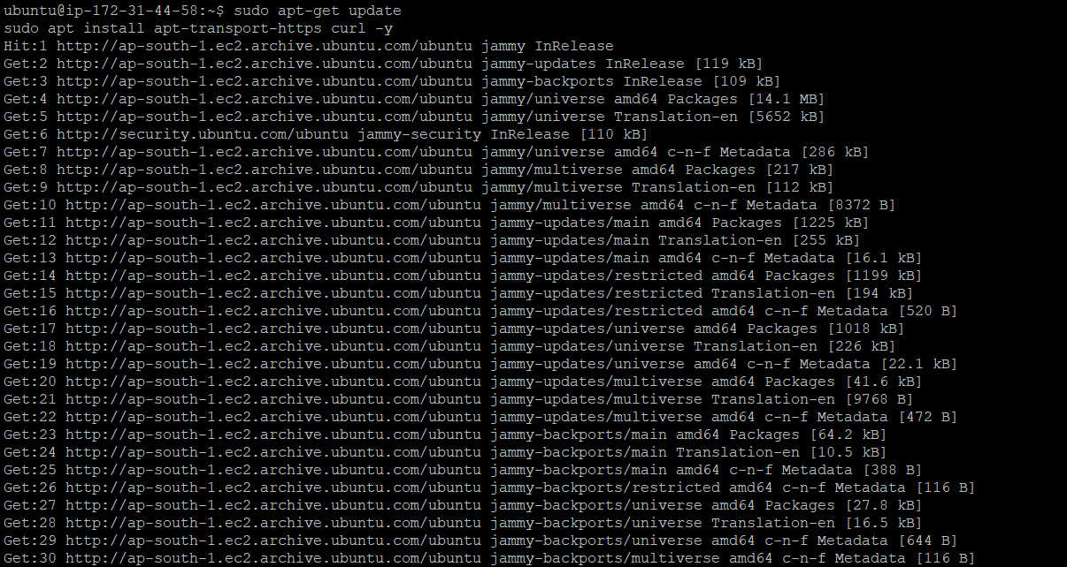

Installed Containerd, used the following commands(Applied to all machine)

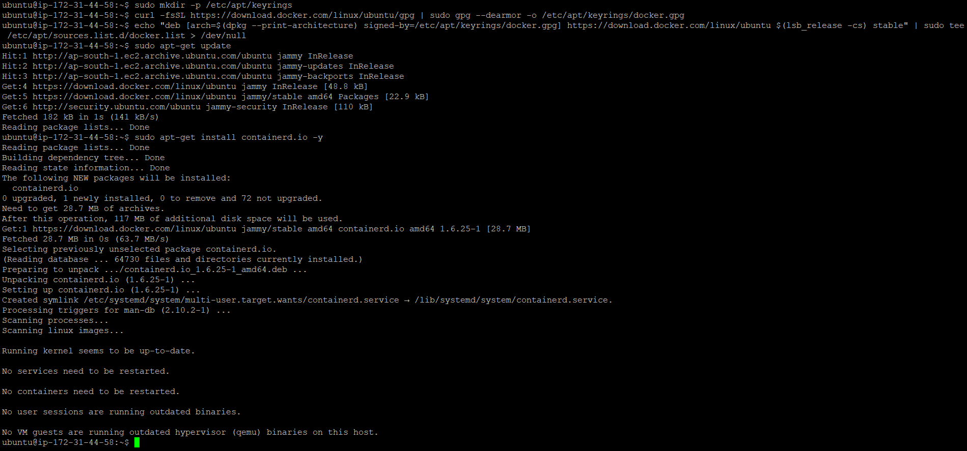

Created the containerd configuration file using the following commands:(On three machine)

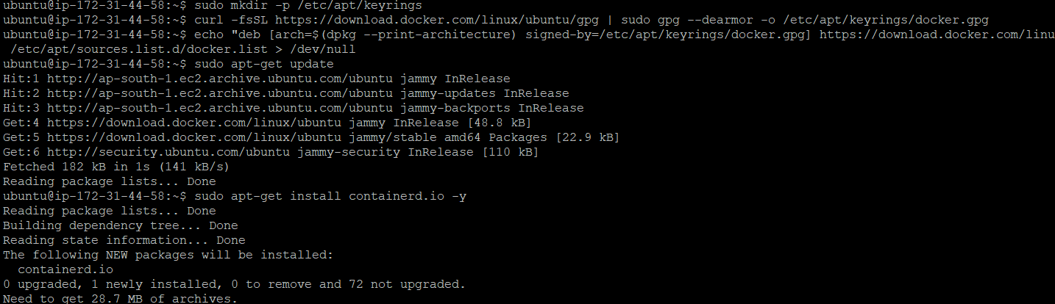

Edited the containerd configuration file to set SystemdCgroup to true. Used the following command to open the file:(Apply to all machine)

Setted SystemdCgroup to true:

SystemdCgroup = true



Restart containerd(Over all machines)

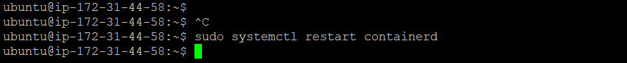

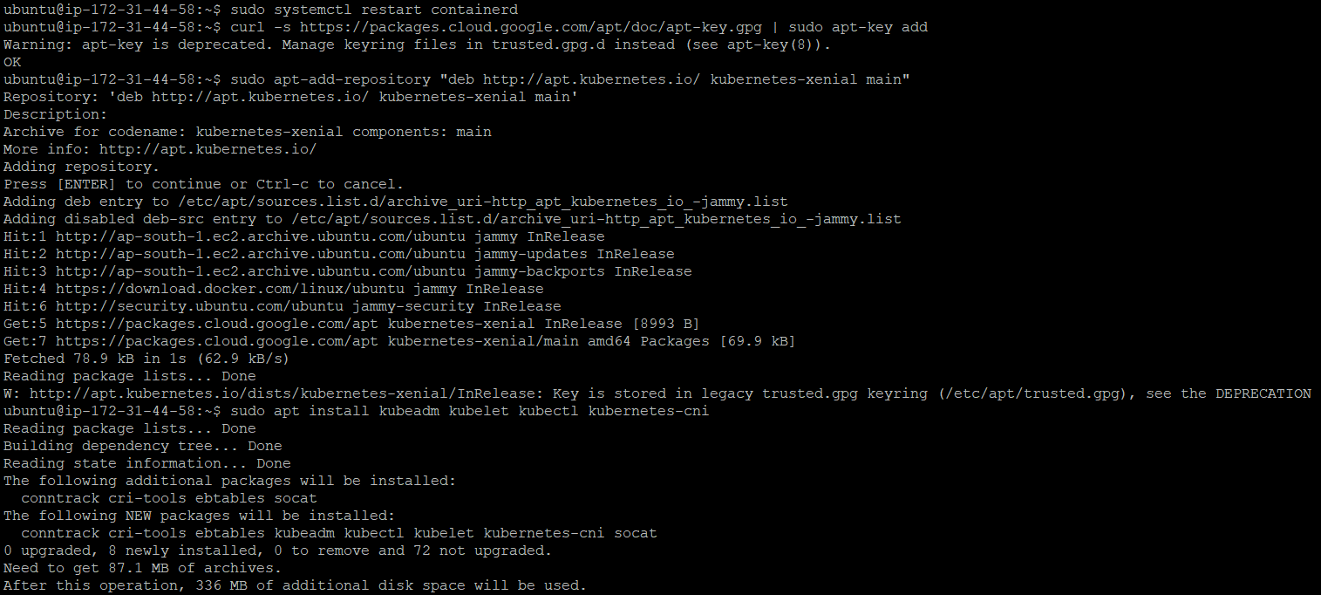

## Initialized the Cluster (only on master) using following command:

## sudo kubeadm init --pod-network-cidr=10.244.0.0/16

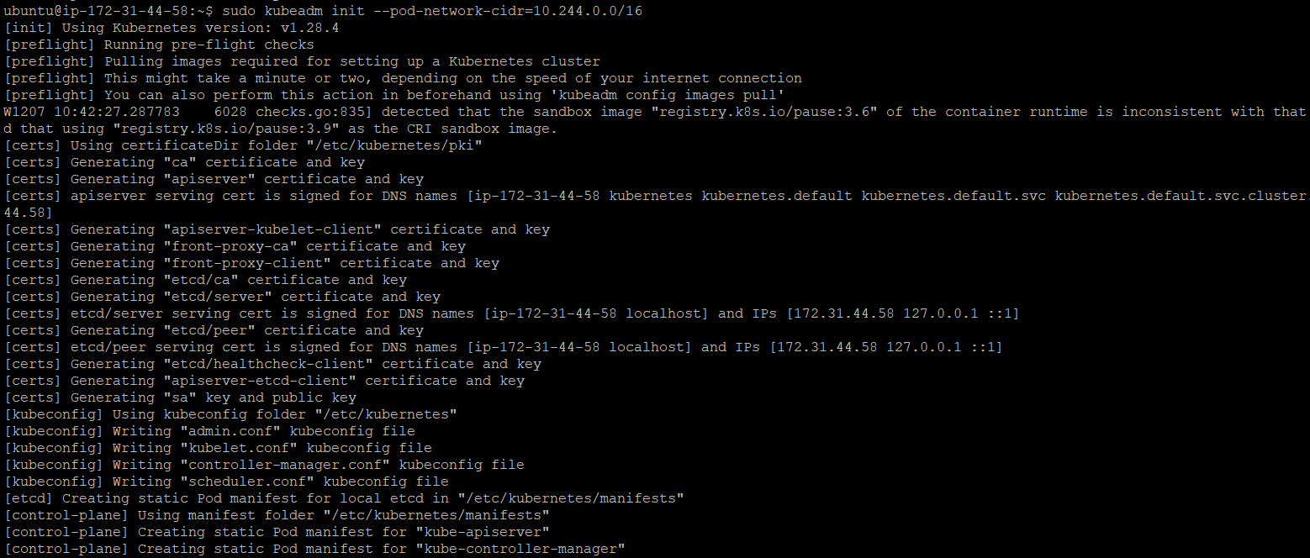

Token :

kubeadm join 172.31.44.58:6443 --token rfqowg.am9ox48rdtqd916j \

--discovery-token-ca-cert-hash sha256:c2ed0eda591385d78738804d83344623a010de047eb0a4018cca65953339fa1d

Created a .kube directory in home directory,Copied the Kubernetes configuration file to home directory and Changed ownership of the file:

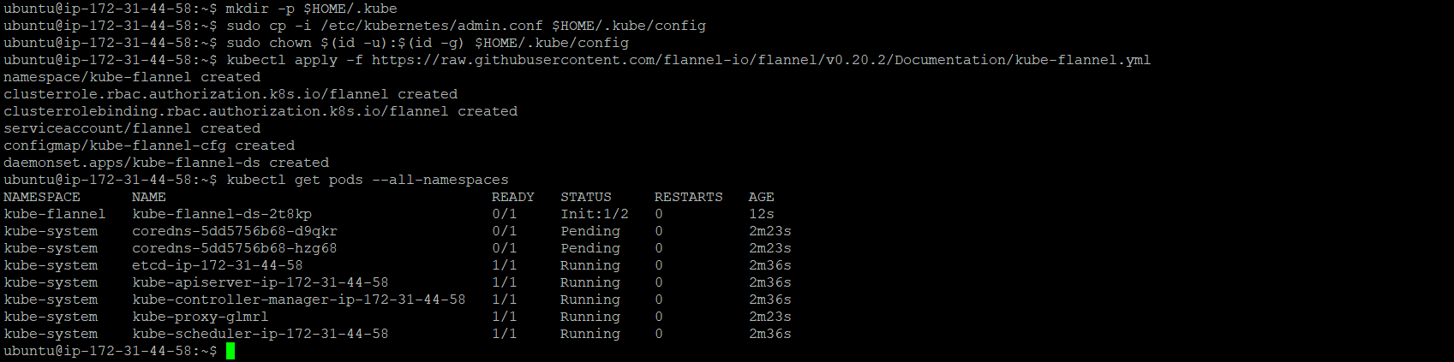

To add nodes to the cluster, run the kubeadm join command with the appropriate arguments on each node. The command will output a token that can be used to join the node to the cluster as below:

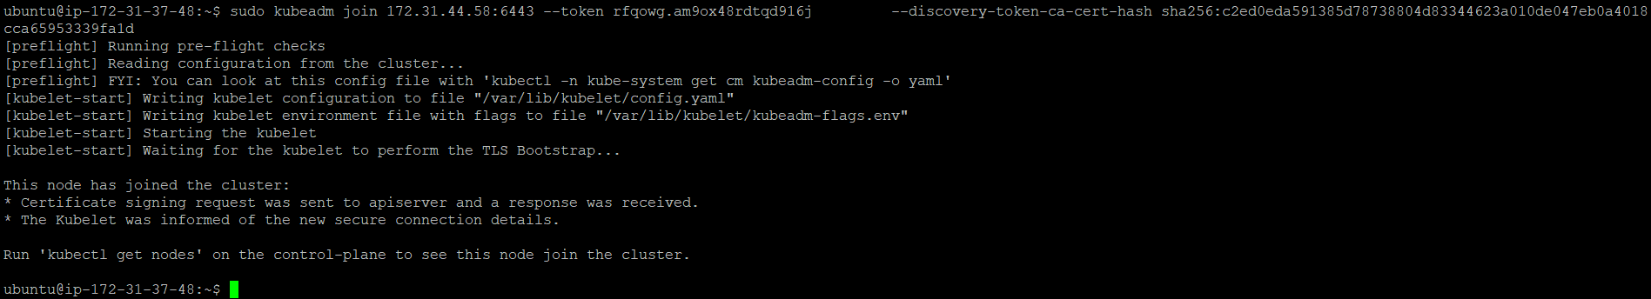

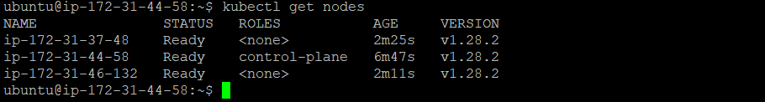



Cassandra.statefulset.yaml:

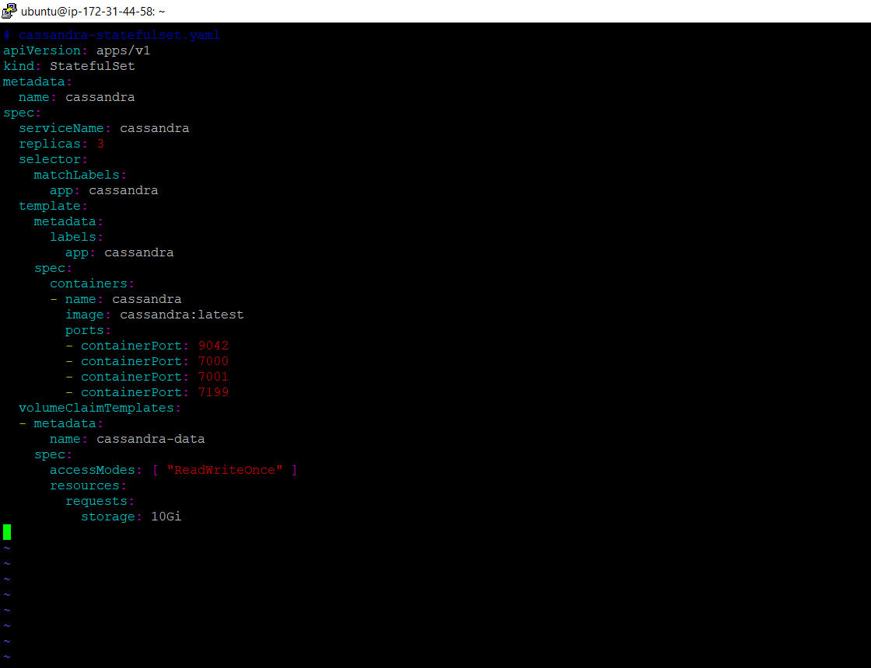

Added port entry 6443,9042

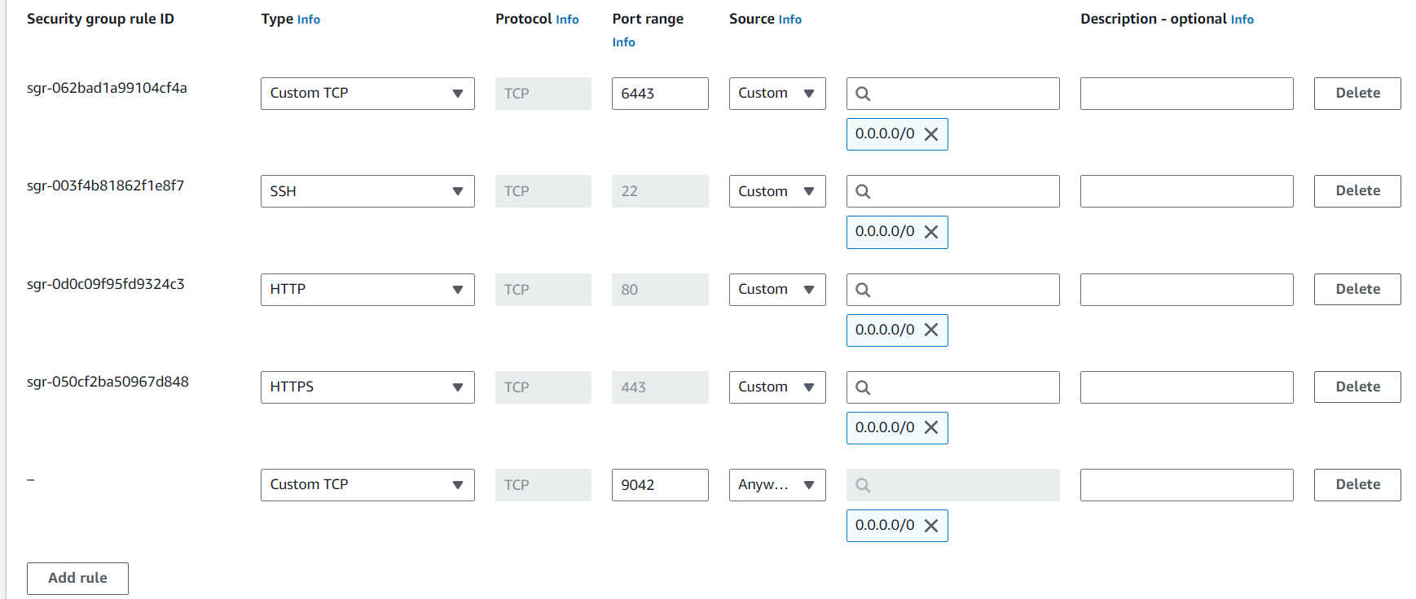

Created a Cassandra deployment as below got the successful result:

